## Optical Odometry Engineering Notes

Kenneth Laws

10/10/2017

HAD – our product is HD Live map, that’s the only product.

This project is to evaluate performance and resource requirements for a visual, sequential image method odometer.

## Epic Story Planning

Odometer Sensor development

Acceptance Criteria:

Test plan for gathering/analyzing data

Identify/gather hardware

Determine compute requirements for real time integration

Phase I

Optical, lidar, ground radar

1. Identify and gather hardware
   1. Identify design parameters
      1. Precision
      2. Accuracy
      3. Operating conditions
      4. Generate draft test plan target design parameters
   2. Hardware selection (selection should include multiple candidates for evaluation)
      1. Sensor candidate selection (e.g., Frame rate, Resolution)
      2. Mechanical OTS
      3. Electrical OTS
      4. In house component design requirements
      5. Draft hardware selection of sensor prototype design plan
   3. Hardware BOM and procurement
2. Test plan for gathering/analyzing data
   1. Design for preliminary small evaluation data set
      1. Simple rig construction to collect small data set
      2. generate test plan for prelim data analysis
      3. conduct prelim experiment and evaluate results
   2. Design for larger (on vehicle) evaluation data set with ground truth
      1. Mechanical system design
      2. Electrical system design
      3. Outline test plan for data collection and data analysis
3. Determine compute requirements
   1. Algorithm selection
      1. Identify candidate algorithms
      2. Algorithm selection trade study
   2. Evaluate processing speed requirements
   3. Outline Implementation strategy
   4. Generate algorithm section of sensor prototype design plan

OBD System

1. Test plan for gathering/analyzing data
   1. Plan to gather velocity data from obd port
   2. Evaluate methods for obtaining obd data
   3. Define test plan for data analysis
   4. Identify best platform available data check sprint
   5. Identify platform independent available data
   6. Collection plan for gathering matchup data
   7. Outline test plan for data collection and data analysis
2. Hardware component selection
   1. Obd interface selection
   2. Data collection/storage hardware
3. Determine compute requirements
   1. Analysis pseudo code
   2. Identify candidate algorithms

Odometery Sensor Development

Phase II

1. Preliminary data (contrast hardware here)
   1. Basic data set (test plan laid out in phase I)
      1. Simple rig constructed to collect small number of images
      2. Constant height above ground
      3. Use candidate camera
   2. Algorithm validation
      1. Process images to compute delta x,y
      2. Accuracy estimate, find key parameters: angle, range in frame, image noise, low light limits, high/low contrast scene
2. Validation prototype
   1. Prototype data collection system
      1. Mechanical design
      2. Electrical design
      3. Deployment plan
   2. Algorithm validation/characterization (test plan laid out in phase I)
   3. Raw data quality assessment
   4. Data product quality assessment

OBD

Phase II

1. Collect candidate data set
2. Compare with highly accurate GPS matchup set
   1. Use GPS position data to evaluate position accuracy
   2. Use change in GPS velocity to evaluate forcing data (accelerator, brake) if available

## Hardware Selection

Pt Grey looks like a good place to start. We have history with the cameras and they seem to be an industry leader. Web site is well organized with tools for camera selection.

Interface: gig E is slower but allows for longer cable. Usb 3.1 is faster and cable length (10 m) is probably long enough for our needs.

Ptgrey

BFS-U3-13Y3C-C 170 fps 1280 x 1024 global shutter

BFLY-PGE-50A2C-CS 13 fps rolling shutter with global reset (used on localization rig)

FL3-U3-13S2C-CS 120 fps 1328 x 1048

Sony industrial – way too expensive

Imperex

B0610 640 x 480 109 fps

B1020 1024 x 1024 60-74 fps

Basler

acA2040-120um - Basler ace

120 fps 2048 x 1536 mono global shutter IMX252

(requested a quote for this camera from Basler)

The above short search indicates that the pt Grey is similar or better than other options. The Basler is an option if higher resolution is needed.

## Identify hardware & design parameters

See: Visual Odometry Hardware and Design Parameters.docx

Downloaded

Installing FlyCap2viewer – done

Flycap viewer is versatile and user friendly. Can easily capture images and save to disk, set frame rate and other parameters.

## Driveway Tests



Camera connector, bulkhead, face view.



## Algorithm Evaluation

Design or select algorithm to reduce raw data to desired data products.  
Test and evaluate different methods,

Determine best data analysis algorithm/strategy for prototype experiments selected

See: Visual Odometry Algorithm Evaluation.docx

## Test Plan Design

11/1/2017

Developed plan for first phase prototype testing.

Visual Odometry Test Plan

11/15/2017

* Purchased, or sent out orders for all hardware, see test plan for table of hardware
* Started a folder for invoices
* Created a git repository for code development
* Got git shell working in windows by changing the default shell to cmd
* Created the git repo on the remote server and cloned it locally
* Modified matlab scripts to improve structure and speed

Time to process one image pair is about 0.29 seconds on my small laptop. This time does not include time to read image data from disk, but does include the time to perform fft and find position shift.

The time measured, using 5 repetitions and averaging, was 0.265 seconds to process one image pair, 1600 x 1200 image with 400 x 200 subframe

Changing subframe and image matrix size to be factors of 2^n helps a little

imageRes = [1600, 1200];

w = 256; % width of subframe

h = 128; % height of subframe

xPix = 1024; % matrix dimensions for image processing factor of 2^n

yPix = 1024;

reduces processing time to 0.20 seconds. Snr improves as the subframe gets larger. No improvement in speed was found making the subframe smaller than 256 x 128.

11/16

* Experimented with frame and image size and found best configuration, processing time about 0.2 sec
* Installed matlab on a T4 PC
* Created a git repo on the T4 PC and cloned the optical odometry repo
* Set up public key access for the repo
* Moved 2 images to a sample image folder and added to the repo
* Tested performance on the T4 PC and found only about a factor of 2 improvement over the laptop, 0.1 sec to process on image file pair

11/20/2017

Looked into speed improvement going from matlab to C. One writeup I found reports speed gains of a factor of 500 to 550. This example included plotting and handling large volumes of data. Another source stated an average improvement of about a factor of 50. Coincidentally, a factor of 50 is about what we need to process images at a rate of 150 fps.

11/22/2017

Evaluating frame rate with Bassler camera

Bassler Ace ACA1920-155UM

11/28/2017

beginning to work on setting up processing in linux.

With Bassler camera, storage options are bitmap or tiff. Tiff has larger file size so going with bitmap.

Set up git repo on linux laptop

branch is

algo_speed_eval

Have captured a couple of sample images from Bassler camera (bmp format)

As of now, lens is 1/1.8 not matched to camera. I was expecting a focused image that just did not fill the frame. What I see is rounded corners without exposure, which is expected, but image is not in focus and not possible to focus with 1/1.8 lens. Hopefully this will be resolved when 1/1.2 lenses arrive.

Working on c-code development

able to compile hello world

want to read in a bitmap file.

I found this info from the web useful: <http://www.instesre.org/howto/BW_image/ReadingBitmaps.htm>

Bitmap files are separated into three or four sections, as shown in the table below.

|  |  |
| --- | --- |
| Section | Description |
| Header | Basic file information, 14 bytes |
| Image Information Header | Information about the image, 40 bytes |
| Color Information (optional) | Information about how the image encodes colors, a variable number of bytes if it's present |
| Image data | The actual image, a variable number of bytes |

14 bytes of the file header

|  |  |
| --- | --- |
| The uppercase characters BM, ASCII codes 66 and 77 expressed as a base-10 integer | 2 bytes |
| File size, bytes | 4 bytes |
| Two "reserved values" that are not needed | 2 bytes each |
| Offset to beginning of image data | 4 bytes |

In principle, it is possible to read these integer values directly by choosing appropriately declared data types that will automatically select the appropriate number of bytes. However, this may give unpredictable results with different C compilers, so I chose a more simple-minded, although probably more tedious solution: read the header one character at a time (characters occupy a single byte) and then use explicit typecasting to force C to interpret each character as an integer.

The two important values in the header are the file size, in bytes, and the offset from the beginning of the file to the start of the image itself, in bytes. The 14 bytes are stored in a character array. The file size starts at element 2 (in C, the first element in an array is 0, not 1) and is stored from low byte to high byte, left to right. I have assumed that even large .bmp file sizes will need no more than 3 bytes. I also declared many of the integer values as type long because the int data type may not be able to represent large file sizes. For the offset value, two characters should always be enough; this value starts at character 10.

|  |  |
| --- | --- |
| Header size, bytes (should be 40) | 4 bytes |
| Image width, pixels | 4 bytes |
| Image height, pixels | 4 bytes |
| Number of color planes | 2 bytes |
| Bits per pixel, 1 to 24 | 2 bytes |
| Compression, bytes (assumed 0) | 4 bytes |
| Image size, bytes | 4 bytes |
| X-resolution and y-resolution, pixels per meter | 4 bytes each |
| Number of colors and "important colors," bytes | 4 bytes each |

The useful values for this image are the width and height, 73 and 70 pixels, and the image size, 73•70 = 5110 pixels. The first byte in the file is at an offset of 0, so an image offset of 54 means that the image starts at the 55th byte in the file. The image is stored line-by-line. Each pixel requires 3 bytes. Each line has an end-of-line mark. So, the image part of the file equals 5110•3+70=15400. Adding the 54 bytes for the header records gives the file size, 15400+54=15454 byites.

Installing openblas-base on my ubuntu system

$ sudo apt update

$ apt search openblas

$ sudo apt install libopenblas-base

$ sudo update-alternatives --config libblas.so.3

Can’t find my path to the openblas library

I need to add something like this to my makefile:

gcc -o test test.c -I /your_path/OpenBLAS/include/ -L/your_path/OpenBLAS/lib -lopenblas

then include

#include <cblas.h>

see [https://github.com/xianyi/OpenBLAS/wiki/User-Manual#link-the-library](https://github.com/xianyi/OpenBLAS/wiki/User-Manual" \l "link-the-library)

12/4/2017

Setting up pbx machine for camera testing.

Installing pylon software

pylon-5.0.11.10914-x86_64 – done

Run pylon viewer by typing: /opt/pylon5/bin/PylonViewerApp

Runs and powers camera OK.

At first, max frame rate was very low (with basler pylon sofware), about 25 fps. Changed: Auto Function Control, Exposure time upper limit to 800 usec and fps increased to 165 fps.

Now able to read images at a rate of 163 fps using OverlappedGrab.c

Frame rate with simpleGrab is only 44 fps. Clearly need to use multiple buffers to achieve desired frame rate.

12/5/2017

Something changed and max frame rate is 155 fps. Not able to find the set of parameters to get the last 10 fps

Exposure Auto, continuous

gain Auto – continuous

Exposure time upper limit – 6000

Auto function profile – Minimize gain

Letting this go for now and continuing to work on code to read a set of images and write them to disk.

Generating file names: I need to compute the offset between strftime() and local_time() in usec, probably also should put the time string in the header of the bitmap file.

Without the ultrafast drive, we can write 20,000 files to disk with an effective frame rate of 138.9 fps. With 30000 files, the rate was 138.2 fps, however, a large number of files had zero size. This appears due to running out of disk space rather than a write speed problem.

Now time to install the M2 drive and redo evaluation with a larger number of files.

12/5/2017

Installing the M.2 drive on the PC planed for running prototype tests.

Cloning the original system drive with CloneZilla, had to make a new bootable clonezilla thumb drive.

Motherboard does not recognize the new M2 drive, looking into upgrading the bios

ASROCK UEFI

X99 Extreme4 P3.30

Intel Xeon E5-2650 v4 @ 2.2 GHz

Installing the Samsung 960 Pro drive was difficult. The drive is of type NVMe SSD and not recognized by the ASUS X99 Extreme4.

Tried updating the bios to latest version but this did not help.

Eventually found an ASROCK forum post related to the problem that revealed that the bios does not see the drive but the operating system can see it anyway. The disk was able to be formatted by running the utility “disk” as admin

sudo gnome-disks.

Then it was possible to format the volume.

Using this high speed volume, am able to capture 40,000 frames at an average rate of 156.2 fps. I believe frame rate in this case is limited by the camera parameter settings not interface or storage speed limitations.

Next up, modify my c program to:

include OverlappedGrab functions,

Set camera parameters

Do timed data collection

12/12/2017

Collecting a 2 minute data set from the camera mounted on car.

Camera: Bassler Ace ACA1920-155UM

Lens: Tamron M112FM12, 12 mm, 1/1.2

Computer: ASROCK UEFI X99 Extreme4 P3.30, Intel Xeon E5-2650 v4 @ 2.2 GHz with Samsung 960 Pro M.2 drive

Need to correct orientation. Need to collect images and check them out. Have installed GPS IMU on my phone and am ready to collect data for ~ 15 minute run. Will need a fast external disk to work with data, could bring one from home.

12/14/2017

Road test experiment:

Collected apprx 10 min of image data with gps imu data from vehicle.

Camera: Bassler Ace ACA1920-155UM

Lens: Tamron M112FM12, 12 mm, 1/1.2

Computer: ASROCK UEFI X99 Extreme4 P3.30, Intel Xeon E5-2650 v4 @ 2.2 GHz with Samsung 960 Pro M.2 drive

Samsung 960 Pro M.2 drive

The computer was powered using a deep cycle, 55 Ahr AGM 12 V battery and the same inverter used for the PBX T4 system.

The camera was mounted to the car using an OTS vacuum cup system



Vacuum cup mounting system used to mount camera on vehicle



Side view of the camera mounting system showing mounting plate and camera.

The system was very flexible in terms of mounting height and orientation, was easily adjustable and rigid. A custom fabricated aluminum mounting was used to attach the camera to the mounting system. Power was supplied to the camera via the USB3 cable connecting the camera to the computer.

Data collection:

First, two sets of calibration frames were collected included a tape measure in the frames. Second, data sets were collected while driving. At least two passes were made over the same roadway to obtain a self-registered data set. GPS data quality was pretty poor. This first test was intended to obtain proof of concept and to develop data processing methods. The height of the camera was measured roughly but the measurement was not recorded. Height was roughly >= 25 cm.

**Data Analysis**

*Calibration:* The calibration data was examined first and results were used as inputs to the processing algorithm in order to produce estimates of vehicle shift calibrated in meters.



Sample calibration image. Axes are in units of pixels. A manual process was used to estimate the conversion from pixels to inches to meters to enable measured registration shifts in units of meters.

Calibration was achieved by dividing the calibration into two sets, the calibration set and the validation set. The calibration set was used to compute the total distance that the vehicle moved in terms of pixels determined by analysis of sequential overlapping images and compare this to the distance that the vehicle moved as estimated by shift along the tape measure visible in the images. The validation set was used to estimate the vehicle position shift measured using the calibration results and compare that to the corresponding shift measured by the tape. There was no overlap between the calibration and validation data sets.



Close up of calibration image showing lines plotted to measure pixels per inch. For this case with lines centered above and below 1052, there are 75 pixels per inch. The number of pixels per inch is found to decrease toward the edges of the image.

Calibration (pix/inch) is a critical element of the process. Calibration can vary over the frame due to distortion of the lens or alignment relative to nadir angle of the camera. Calibration for this prototype experiment was measured over a range of locations along the long axis of the image and in the region of the inch markings on the tape measure. The approximate location of the maximum pixel density was found and then the pixels per inch image resolution was plotted as a function of the absolute value of the number of pixels from the maximum location.



Pixel per inch resolution as a function of distance from maximum resolution location with linear fit. Coefficients of the linear fit and the location of maximum resolution are given on plot.

With the above calibration information, the distances in inches between any two points on the image can be approximated by numerical integration.

The above calibration method should be improved by repeating calibration using two tape measures, perpendicular and intersecting at the approximate center of the calibration image. Also, this calibration will vary with vertical distance from camera mount point to ground. This distance should be measured using ultrasonic range finder and the dependence on range evaluated.

Analysis of the calibration set calib2:

There are 301 images in the data set. The first 150 images have the tape measure present in the image. Distance travelled by analysis of sequential images can be compared with distance travelled as measured by the tape. (vehicle speed was about 1 m/s). Distance travelled as determined by images was 50.51 inches. Distance as determined by tape was 19 ½ to 77 – 19.5 = 57.5”.

Calibration needs improvement. I did not include deviations in x position (only y) and this will push result in the right direction.

Scripts are pretty useful at this point and in good shape but

* Would be good to have an image viewer that can pick an image from a folder using the gui
* Need to include x deviations in position and compute total displacement
* Probably need to improve calibration
* Want to be able to plot speed in m/s for a specific data set
* Want to be able to print total displacement for a given data set
* Want to be able to plot displacement vs time

1/8/2018

Have redone calibration and improved the way calibration date is used. Recomputed the total distance traveled from image 0 to image 141 = 1.2165 m

measured distance = 132.7 – 6.6 cm = 126.1 cm

Reviewing calibration, using image pair 114/115 where computed movement was 2.59 cm, measured movement was 2.7 cm. There are problems with the calibration method.

Recalibrating on selected images starting with the 114/115 pair

2.71 2.70

3.06 3.0

3.34 3.3

3.62 3.55

3.8 3.75

modified calibration number to make these 5 pairs agree pretty closely with the distance on the tape

Recomputed all delta y's with the modified calibration and reprocessed data

New total delta y was 125.4 cm, compared with 126.1 cm measured, error = 0.7 cm

Above calibration data is not accurate enough. Try a new method that makes the total distance traveled over part of the total range of image files equal to the sum of dy retrievals. Then compare to a different set of files from the same calibration set.

Define this as a new calibration function.

Third Calibration Effort



Plot of position shifts derived from sequential images from the calibration/validation data sets. Data points in the range of image number 50 to 110 were used for calibration. Points from 111 to 141 were used for validation.

For the calibration data set, the vehicle shift was summed over 61 image pairs for a total of 2054 pixels in the direction of the long axis of the image frame, approximately parallel to the vehicle axis. A shift of 10 pixels was found for the corresponding sum over the short axis of the image frame (an indication of a small misalignment of the camera). This shift in the short access of the image was neglected. Direct measure by examination of the tape showed that the vehicle moved 71.91 cm, giving a calibration value of

C = 0.7191/2054 m/pix

C = .35 mm/pix

Speed Resolution = C*frame rate = 0.35E-3 * 156.2 = 0.055 m/s

This calibration value was used to estimate the distance moved over the validation data set (images 111 to 141). The estimate of vehicle motion using image pair shift over the 32 image pairs in the validation set was 1553 pixels (0.5437 m) and by direct measurement the vehicle motion was 0.5426 m, giving an error of 0.0011 m. If we estimate the error per measurement as total error divided by the square root of the number of measurements, the error per measurement was about 0.2 mm, which is roughly equivalent to the uncertainty in reading the tape measure in the image frames and therefore corresponds to the limit in the accuracy of the calibration.

Neglecting x transition, calibration is 132.2/2054 cm/

Distance by direct tape measurement:

Checking registration marks:

img 227_49 == 132.2cm

img 239_110 == 60.29

Total distance = 71.91 cm

1/16/2018

*Vehicle Speed:* Given that time between sequential frames is constant, position shift translates directly to speed. Speed is easier to evaluate initially, an absolute measurement that can be compared directly to GPS speed estimates, initial examination of the calibrated sequential image results are done in speed.



First 10 seconds of Test Drive_1214 showing vehicle slowly accelerating from stop. Two failures are visible in the retrievals, image pairs 991 and 1138.

Signal to noise ratio corresponding to above plots is reduced for the failed retrievals.

Examination of the apparent error at image 991 shows that the image did actually shift a large distance. The reasons for the large shift between image image pairs is unknown. For the apparent error at image pair 1138, the failure seems to be with the data. The sequential images to not appear to have any overlap.



Image pair 1138 do not overlap. The red boxes show the first image target section, and the second image location of the target on the reference image.

It appears from the results of the first 10 seconds of the data that the data collection was stopped and restarted, or otherwise became out of sync in time and vehicle position.

The second ten second segment of the drive (101400 time stamp) contains larger vehicle speed and more image registration failures.



Plot of retrieved vehicle speed for time segment 101400 (10 sec)

Plot of snr of position shift retrievals. Decrease in snr with increase in vehicle speed is apparent.



Example of a failed retrieval due to lane and crosswalk markings (image pair 194)

Retrieval failures

101400

193 -201 image saturated in target region

298 image saturated in target region

553 Poor match between target and template

621 target looks good, correlation has many peaks

871 retrieval is at edge of image

1022 retrieval is at edge of image

1078 retrieval is at edge of image, multiple peaks in correlation

1110 retrieval is at edge of image, multiple peaks in correlation

1120 retrieval is at edge of image, multiple peaks in correlation

1127 retrieval is at edge of image, multiple peaks in correlation

1/19/2018

Analysis of set 101400

1561 image pairs

Apparent actual max vehicle speed = 11.48 m/s

number of data points with speed > 13 m/s = 22

number of points with speed < 0 m/s = 3

Fraction of points with high error = 25/1561 = 1.6 %

*Image saturation:*

In cases of image saturation 193 – 201, most cases show saturation of < 95%

mitigate by looking for the case of saturation 95 % and rejecting those points. Store saturation and black fraction with the retrieval for post processing.

*retrieval is at edge of image:*

Some cases where the image was mostly saturated resulted in retrievals where the target was located at the top edge of the image. These cases can be rejected by checking for target at edge. The edge variable set > 0 for top, bottom, left, right cases.

553 Poor match between target and template:

the template is located on an unusually dark patch of tar on the road. The selected target is found on a patch of white paint. This condition can be identified by a poor match between the normalized target and template regions. Average match values examined fall around or below 2000. The identified mismatch case had a match value of 35,000.

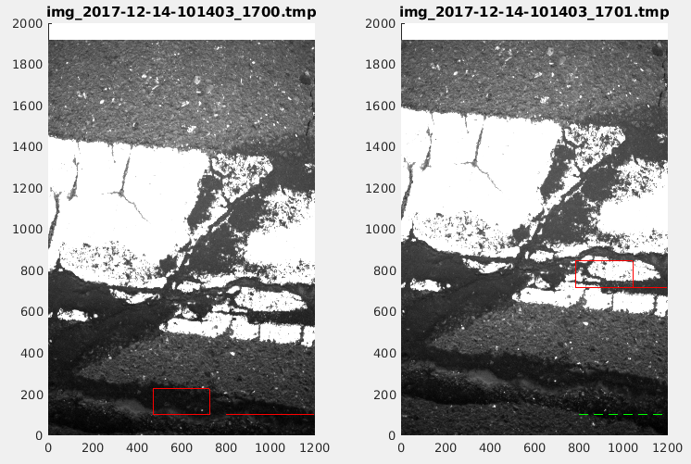

Example of bad retrieval that can be rejected by a poor match between the template and the target

621-623 target looks good, correlation has many peaks, result is at edge of image

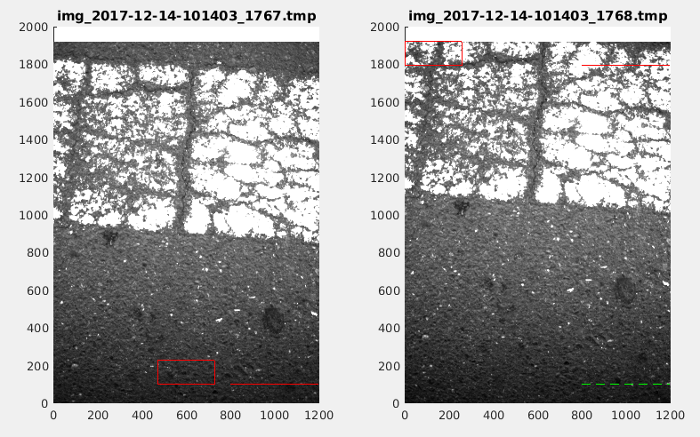

Failed retrieval, target found at edge of image.

It is not clear why the edge of the image has a high phase correlation, but I suspect that using a windowing before the FFT might resolve the problem. For now, having a check that rejects selection of edge regions will suffice to remove the bad data for this case. Also, I suspect the vehicle may be turning here and this may explain why the correct result is not captured.

871, target selected at top edge of template

1/22/2018

Reprocess 101400 data with data rejection

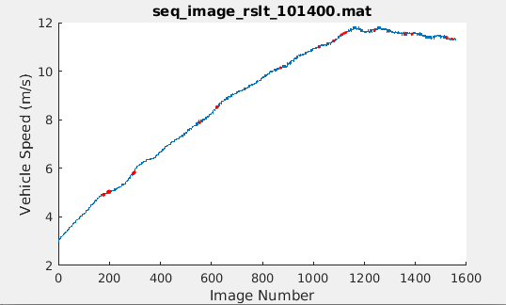

First 10 seconds of speed data, gaps from rejected data filled (red)

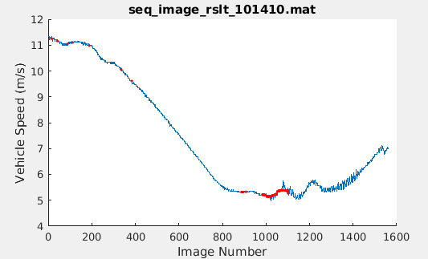

Second 10 seconds of speed data, gaps from rejected data filled (red)

1/28/18

With data rejection and gap filling in place, process the whole drive data set.

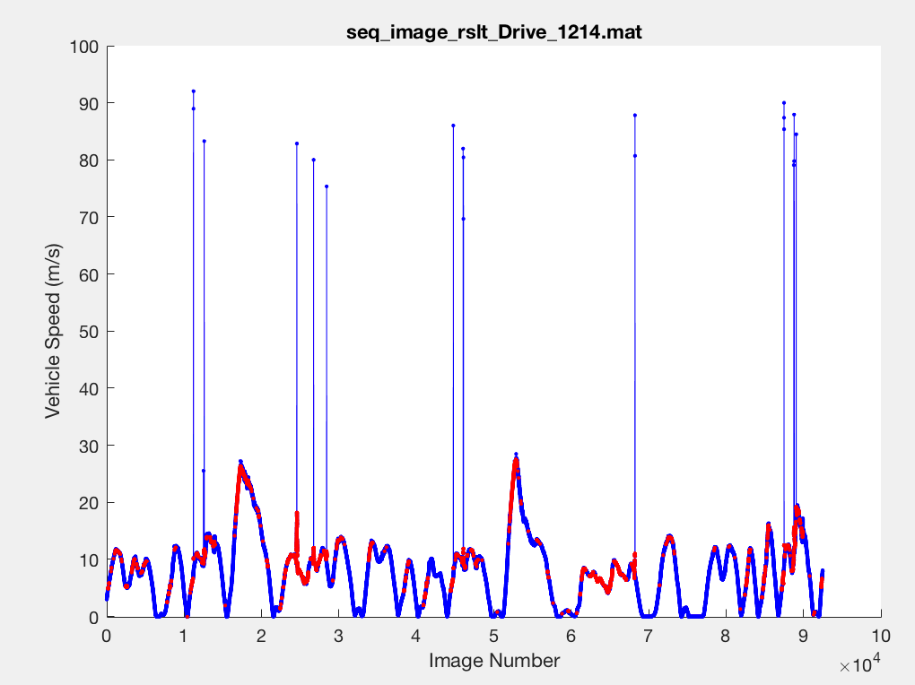

Vehicle speed over the entire 10 min drive test. Some obviously bad data got through the data rejection algorithm and there are a very large number of rejected data points. Many of these are due to target located at the image edge.

Results from processing of 1214 data set indicate a large number of data rejections come from selection of edges. This may be due to the need for windowing the data before taking the FFT.

1/28/18

Attempted to apply Han window to the data but was not able to reduce edge effects

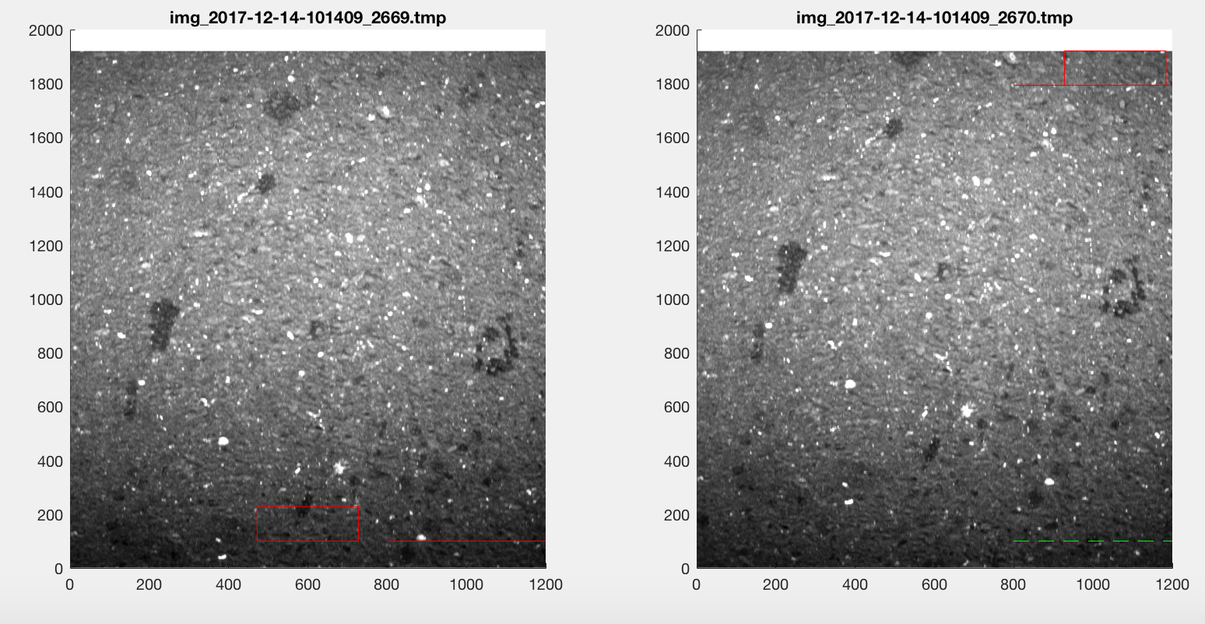

Example of edge selection error

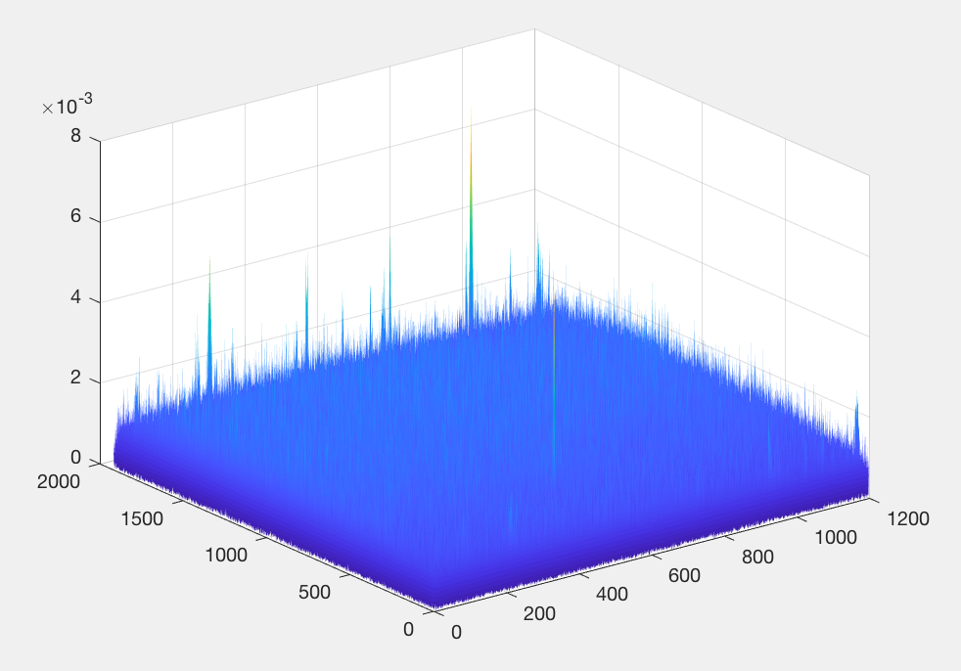

Corresponding cross-correlation: the correct result is the very narrow peak near location (500,500) the maximum peak, however, is at the edge near (1000,1900).

Application of Han window did not improve the above example. I tried putting a 2d window on just the target region, on just the reference image, on both the target and the reference. None of these seemed to have any effect towards reducing the peaks at the edges.

The next strategy is to zero out the edge regions of the cross-correlation matrix. Just rejecting the selected bad data is not the best strategy because those points have to filled using interpolation and the actual retrieval solution is lost. In cases such as the above, the best retrieval solution would be selected if the edge solutions were removed. By making sure that the speed solutions that are removed are not attainable by the vehicle based on physical principles, no useful information is lost.

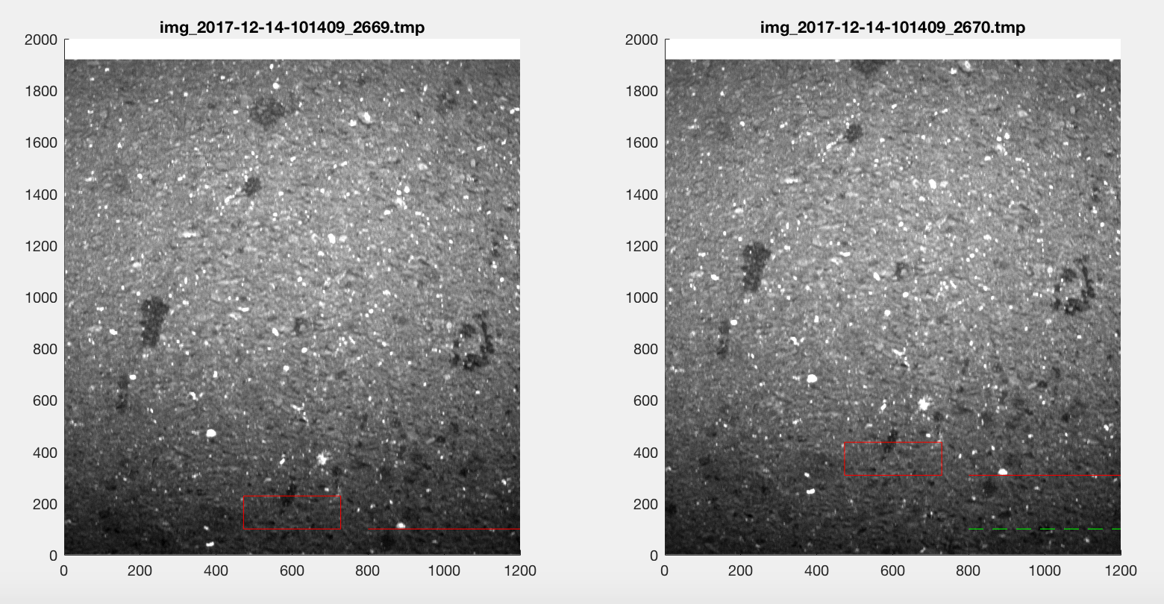

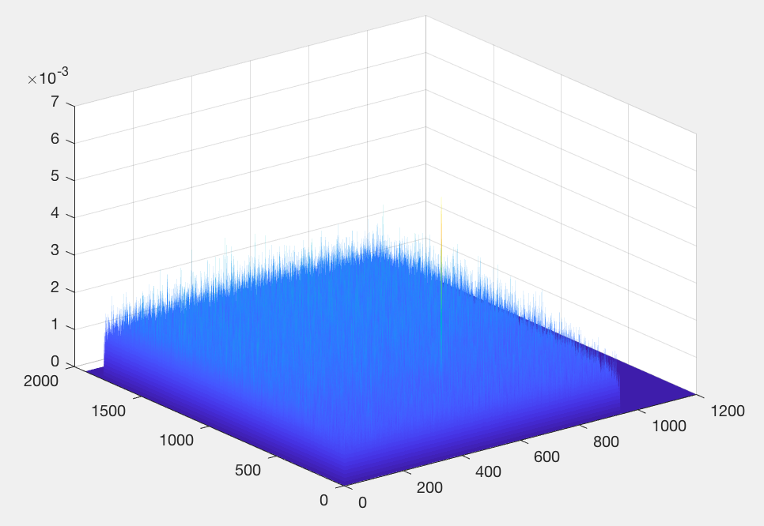

*Investigating the remaining missed bad data points:*

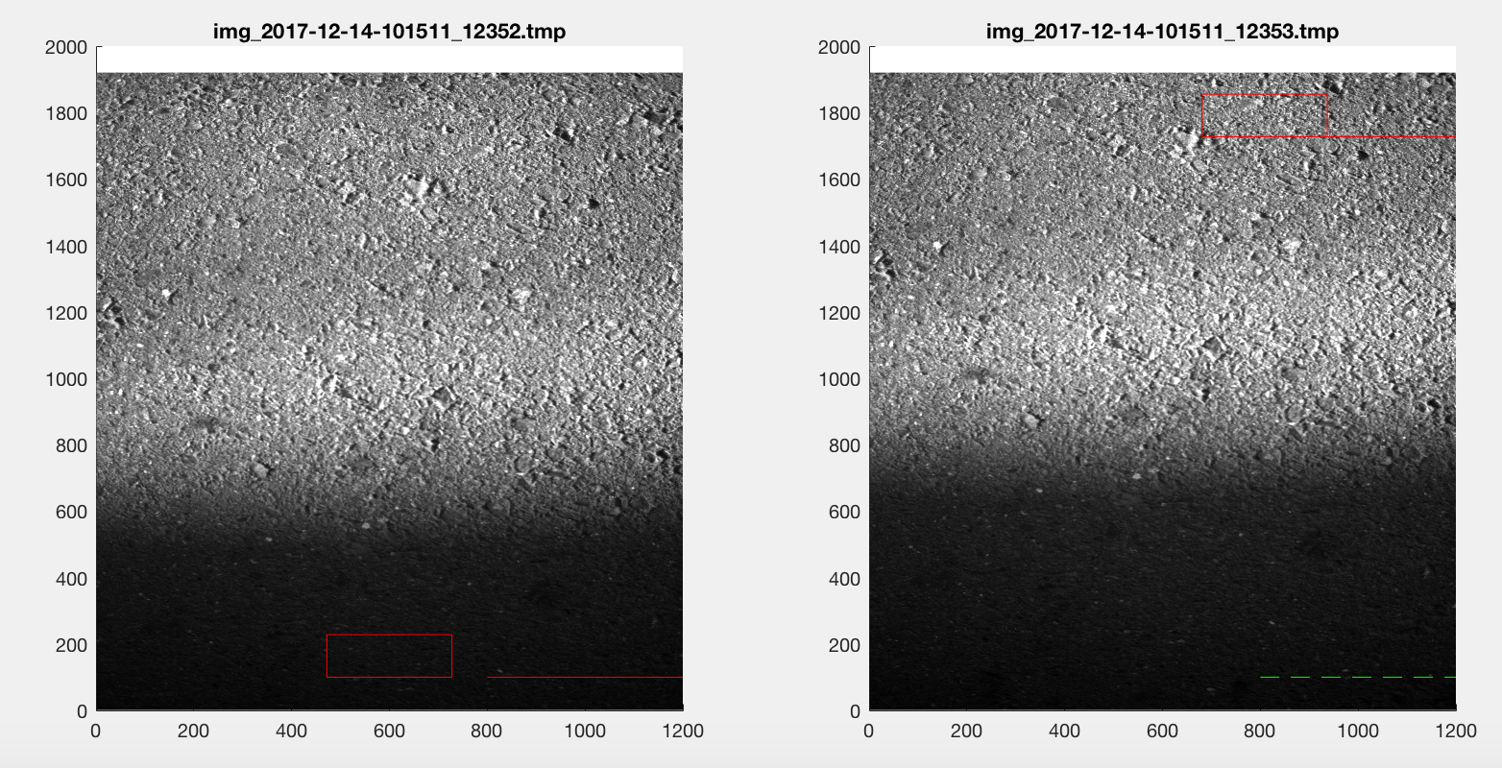

Reject algorithm failed: clearly a big shadowing problem (would be great to have some illumination under the car, perhaps red LED) selected target is not at edge but mismatch algorithm should have caught this case.

11205 template in shadow, high ND 9634 but below threshold, target near top

11206 template in shadow, high ND 8539 but below threshold, target near top

12489 train tracks in frame, light smooth concrete, many ambiguities

12494 train tracks in frame, template in nearly black region but FB=0, ND 8512, snr 8.5 (nearest ambiguity has similar snr)

24560 In this region of data, the shadow of the car is partially in the image. This causes a high mismatch value even when the algorithm is successful. The mismatch parameter may not be a good filter.

The threshold for normalized difference was set arbitrarily at 10,000. The above case (step 11205) had a value of 9,634. The next step was also bad and failed to be rejected, ND = 8539. Note that both cases could have been rejected for speed too high, out of range.

Made some modifications to process again

1. zeroed out edge regions

2. increased the normalized difference limit – this metric rejects good data

3. added an ambiguity metric that looks at the nearest ambiguity in correlation value, and where it is located in image shift space

2/1/2018

After reprocessing with edge rejection:

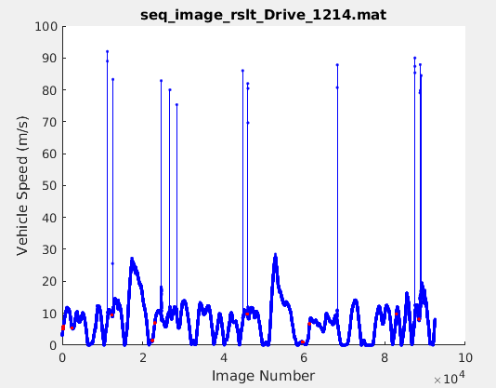

Drive 1214 results after reprocessing with edge rejection. Number of rejected data points is vastly reduced. Some outliers remain. Note that there might be an issue with missing data between 11205 and 11206

Analysis of bad points:

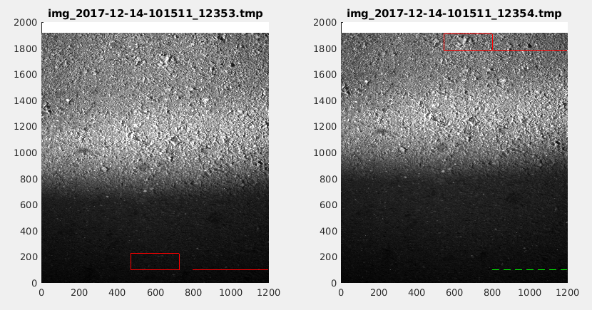

Bad point 11206: not quite at the edge region so not rejected. The new ambiguity check finds snr = .061 and ambg peak is [15 396] pix away (not close) the last good point had similar snr but ambg peak was within 1 pix.

Data check program not working right, images are not sequential, don't match results plot

check

11200 7.765

11201 7.820

11202 7.820

11203 87.23

found problem with data check program – I was loading an old “filtered result” file. Changed code to ask to use precomputed filtered data result or to compute new.

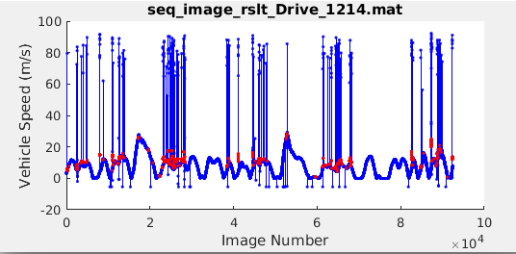

Results after modifications to data rejection: missmatch not beeing used (not useful) edge cases not allowed so next best peak is selected (often good solution) ambiguity method is a good candidate to catch the rest of the missed bad points

To work on improving data rejection, going to focus on first 20% of the data set. This is to speed up processing. Want to find the peak in the correlation, then zero out the region around the peak, then find the next highest peak and evaluate the snr.

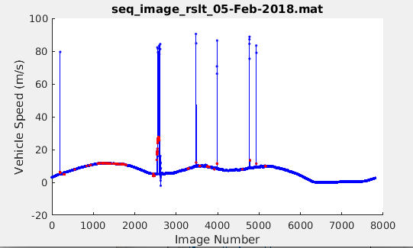

Partial set processing: fraction of rejected points is better than it looks, SNR for ambiguity rejection is lowered to 2.

First issue, saturated at 88%, passed threshold of 95%, lowered threshold to 80% This saturation was due to paint on roadway.

Second issue 2547: found bug in normalizing cross-correlation

2557: image has shadow, very poor snr, should have been rejected (bug above)

reprocess data set with bug fix

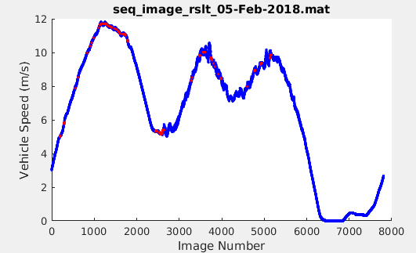

After reprocessing high error data points have been eliminated and data rejection is only 2.94 %.

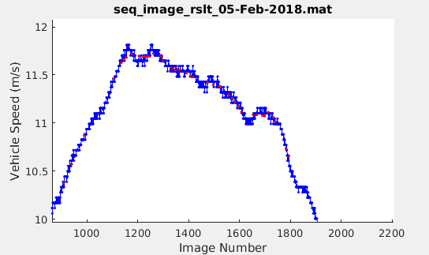

Close up of region of data with high data rejection shows that even in this region there are enough good points to get a good estimate of measured speed.

Switched to linear comparison of solution and ambiguity correlation values and set minimum ratio to 1.5. Manual inspection shows good data are still being rejected with this setting. Reprocess entire data set with these settings.

Result in processing Drive 1214. Processing tools now successfully remove all outliers and fill resulting gaps. Fraction of rejected data is 3.88 %. Tag v0.0.1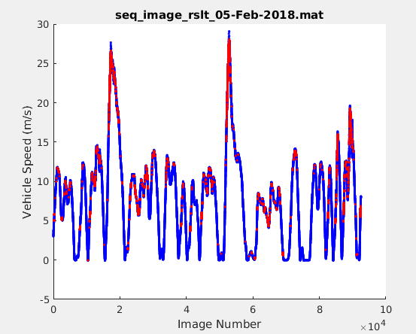

Results from latest processing look good. All outliers caught, all gaps filled low fraction of rejected data. Total distance traveled is 4605.27 m.

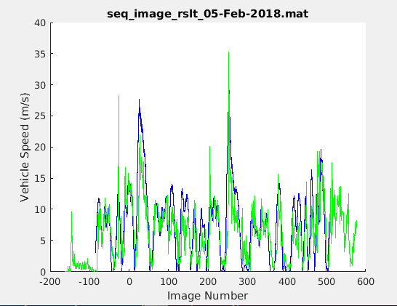

Plot of vehicle speed as observed by sequential image processing (blue line) with gps speed overlaid (green line).

Comparison of results for one dim speed estimates obtained from image processing with gps results qualitatively agree but noise in gps measurements is very high and so comparison gives little new information.

2/6/2018

Compare distance traveled

Very large difference between gps and image processing. Have looked at one straight stretch of road. I will try and repeat calculation for the same stretch of road but on the second pass.

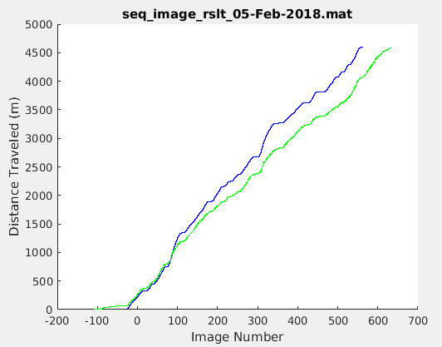

Accumulated distance traveled, image (blue line) and gps (green line). I have concern that the sum of gps (dx^2 + dy^2)^1/2 is not accurate. Next plot chooses a straight section of the drive and uses start and end point gps to compute distance to compare to accumulated image processed results.

Applying an arbitrary calibration shift to make the total distance traveled agree

Application of a .85 scaling factor on the image data makes the accumulated distance line up and it can be seen that the features are well tracked in by the image data. Since the data have different granularity, it is difficult to compute rms error. With this .85 calibration factor, there are times when the image data consistently over estimate the GPS and times when they under estimate GPS. The theory at this point is that this is due to shifts in camera height due to speed and/or acceleration.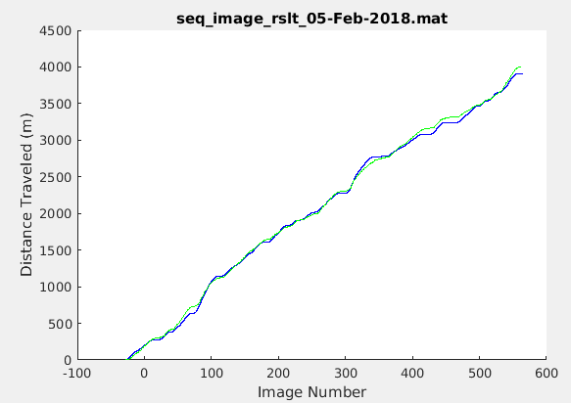

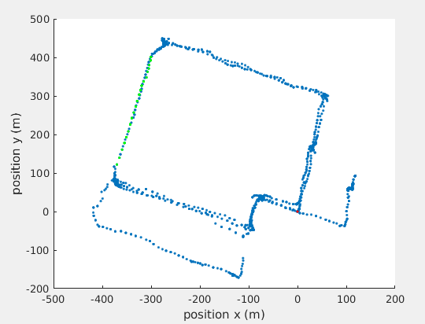

Drive 1214 route, selected straight section (green dots)

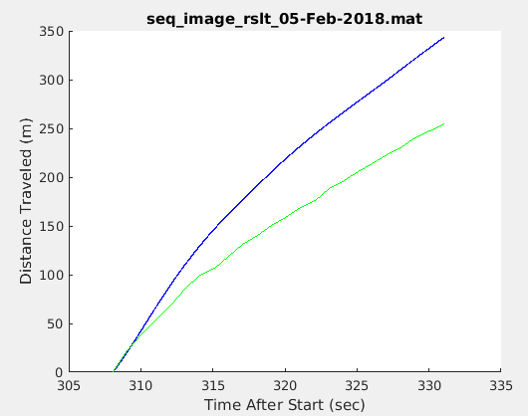

Comparison of image data to GPS data for the selected straight route portion. Accumulated distance for the gps is 297.084 m. Difference between start and end points for the GPS distance is 296.186 m. Accumulated distance for the image data is 383.996 m (this includes the .85 calibration factor). Image data is over estimating distance traveled by about 30%.

Heading extraction

Heading can, in principle be extracted using the difference in shift between templates locted on different sides of the frame. The change in heading (radians) is given by

dTheta = dShift/dTemplate

where dShift is the different in shift of the two template regions and dTemplate is the difference in location (right/left) of the template regions.

The result is somewhat inconclusive with some features agreeing with gps heading measurement and some not. Of issue seems to be the resolution of the measurement. Heading shifts are often 1 pixel or less so the resolution of the measurement is significant compared to the measurement itself. Results might be improved by using centroid calcution to obtain sub pixel resolution of the image shift. It is likely, however that the noise in the measurement would still be a problem.

Heading computed from image processing (blue line) and from gps (green line). Some arbitrary calibration shifts were applied. The data show some of the features in the gps data but there are clearly some problems. 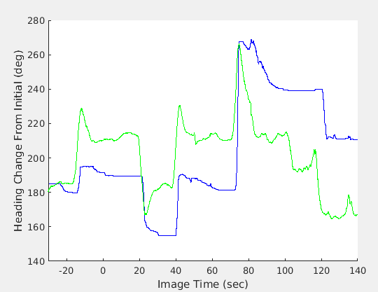

Next step is to set up for another experiment that will include a rangefinder and probably better GPS data.